REPORT OF THE
COMPTROLLER AND AUDITOR GENERAL OF INDIA
FOR THE YEAR ENDED 31 MARCH 2010 (LOCAL BODIES)
GOVERNMENT OF ANDHRA PRADESH
HOME |  | PREFACE | OVERVIEW
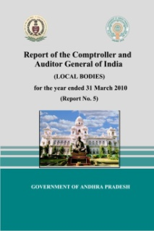 | TABLE OF CONTENTS
- ADILABAD | CHAPTER I
- ANANTAPUR | OVERVIEW OF ACCOUNTS AND FINANCES OF LOCAL BODIES
- CHITTOOR | Sn-A Overview of Accounts and Finances of Local Bodies
- EAST GODAVARI | Sn-B Financial Reporting
- GUNTUR | CHAPTER II
- KADAPA | PERFORMANCE AUDIT REVIEWS
- KARIMNAGAR | Municipal Administration and Urban Development Department
- KHAMMAM | 2.1 Functioning of Anantapur Municipal Corproation in Sanitation, Water supply, Property tax, Shopping complexes and Municipal schools
- KRISHNA | Panchayat Raj and Rural Development Department
- KURNOOL | 2.2 Functioning of Zilla Praja Parishads in Anantapur and Guntur districts
- MAHBOOBNAGAR | CHAPTER III
- MEDAK | AUDIT OF TRANSACTIONS
- NALGONDA | Panchayat Raj and Rural Development Department
- NELLORE | 3.1.1 Violation of Government of India instructions and submission of false Utilisation Certificates
- NIZAMABAD | 3.1.2 Diversion of House Building Advance recoveries in violation of State Government orders
- PRAKASAM | 3.1.3 Non transfer of earmarked funds by PRIs to various Corporations
- RANGAREDDY & HYDERABAD | 3.1.4 Undue favour to a firm
- SRIKAKULAM | 3.1.5 Loss of revenue
- VISAKHAPATNAM | Municipal Administration and Urban Development Department
- VIZIANAGARAM | 3.2.1 Irregular raising of loan
- WARANGAL | 3.2.2 Construction of Rain water harvesting pits
- WEST GODAVARI | 3.2.3 Undue benefit to contractors
 | 3.2.4 Non augmentation of revenue
 | 3.2.5 Payment of family pension
HOME

